**SQL FOUNDATION L1**

1. Write a SQL statement to Create below table.

SQL> CREATE TABLE SALES(

SALESMAN_ID INTEGER,

NAME VARCHAR2(20),

CITY VARCHAR2(20),

COMMISION NUMBER(5,2)

);

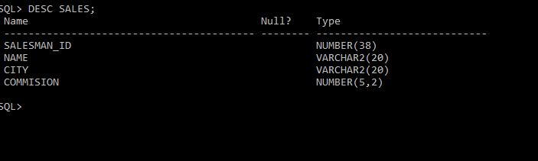

INSERT INTO SALES VALUES(5001,'JAMES HOOG','NEW YORK',0.15);

INSERT INTO SALES VALUES(5002,'NAIL KNITE','PARIS',0.13);

INSERT INTO SALES VALUES(5005,'PIT ALEX','LONDON',0.11);

INSERT INTO SALES VALUES(5006,'MC LYON','PARIS',0.14);

INSERT INTO SALES VALUES(5003,'LAUSON HEN','SYDNEY',0.12);

INSERT INTO SALES VALUES(5007,'PAUL ADAM','ROME',0.13);

SELECT * FROM SALES;

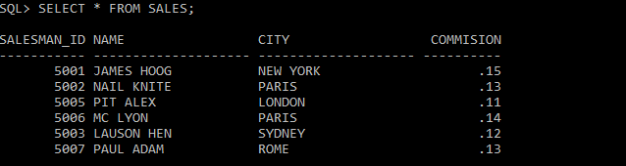

2. Write a SQL statement to display specific columns like Salesman_id and Name from above table.

SQL> SELECT SALESMAN_ID,NAME FROM SALES;

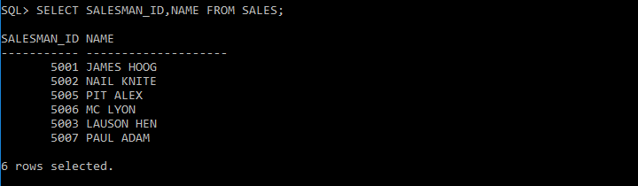

3. Write a query to display Name column in accending order from above table.

SQL> SELECT NAME FROM SALES ORDER BY NAME;

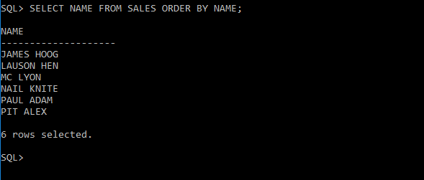

4. Write a SQL statement for above table to diplay names and city of Salesman, who belongs to the city of Paris.

SQL> SELECT NAME,CITY FROM SALES WHERE CITY = 'PARIS';

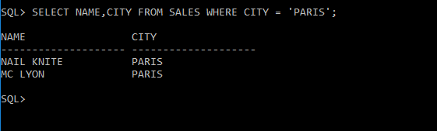

5. Write a query on above table to filter those salesmen with all information who comes from any of the cities Paris and Rome.

SQL>SELECT * FROM SALES WHERE CITY ='PARIS' OR CITY = 'ROME';

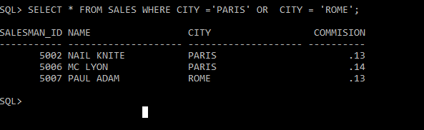

6. Write a SQL statement to find those salesmen with all the other information and name started with any letter wining ‘A’ and ‘K’ from above table.

SQL> SELECT * FROM SALES WHERE NAME LIKE 'A%' OR NAME LIKE 'K%';

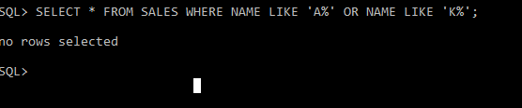

7.Write a SQL statement to display all the information for those customers with a Grade of 200.

CREATE TABLE CUSTOMER

( CUSTOMER_ID NUMBER(10) NOT NULL,

CUSTOMER_NAME VARCHAR(50) NOT NULL,

CITY VARCHAR2(50),

GRADE VARCHAR2(50),

SALESMAN_ID NUMBER(10)

);

INSERT INTO CUSTOMER VALUES (3002,'Nick Rimando','New York',100,5001);

INSERT INTO CUSTOMER VALUES (3005,'Graham Zusi','California',200,5002);

INSERT INTO CUSTOMER (CUSTOMER_ID,CUSTOMER_NAME,CITY,SALESMAN_ID)VALUES (3001,'Brad Guzan','London',5005);

INSERT INTO CUSTOMER VALUES (3004,'Fabian Johns','Paris',300,5006);

INSERT INTO CUSTOMER VALUES (3007,'Brad Davis','New York',200,5001);

INSERT INTO CUSTOMER VALUES (3009,'Geoff Camero','Berlin',100,5003);

INSERT INTO CUSTOMER VALUES (3008,'Julian Green','London',300,5002);

INSERT INTO CUSTOMER VALUES (3003,'Jozy Altidon','Moscow',200,5007);

SQL>SELECT * FROM CUSTOMER WHERE GRADE=200;

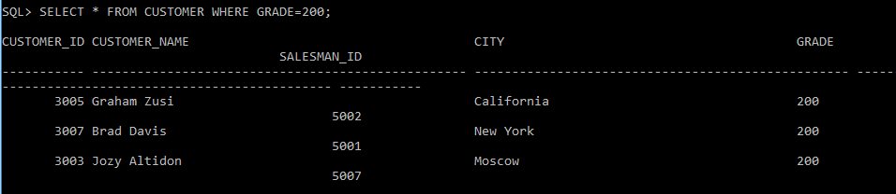

CREATION

--------------------------------------------------------------

CREATE TABLE MANUFACTURER(

2 PRO_ID NUMBER(4),

3 PRO_NAME VARCHAR2(15),

4 PRO_PRICE NUMBER(4),

5 PRO_COM NUMBER(3));

INSERTION

--------------------------------------------------------------

BEGIN

INSERT INTO MANUFACTURER VALUES(101,'Mother Board',3200,15);

INSERT INTO MANUFACTURER VALUES(102,'Key Board',450,16);

INSERT INTO MANUFACTURER VALUES(103,'Zip drive',250,14);

INSERT INTO MANUFACTURER VALUES(104,'Speaker',550,16);

INSERT INTO MANUFACTURER VALUES(105,'Monitor',5000,11);

INSERT INTO MANUFACTURER VALUES(106,'DVD drive',900,12);

INSERT INTO MANUFACTURER VALUES(107,'CD drive',800,12);

INSERT INTO MANUFACTURER VALUES(108,'Printer',2600,13);

INSERT INTO MANUFACTURER VALUES(109,'Refill cartridge',350,13);

END;

8. Write a SLQ query to calculate the average price of all products of the manufacturer which code is 16.

SQL> SELECT AVG(PRO_PRICE) FROM MANUFACTURER WHERE PRO_COM=16;

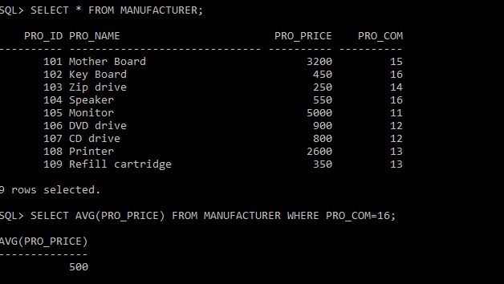

9. Write a SQL query to find the name and price of the cheapest item from above table.

SELECT PRO_NAME,PRO_PRICE FROM MANUFACTURER WHERE PRO_PRICE=(SELECT MIN(PRO_PRICE) FROM MANUFACTURER);

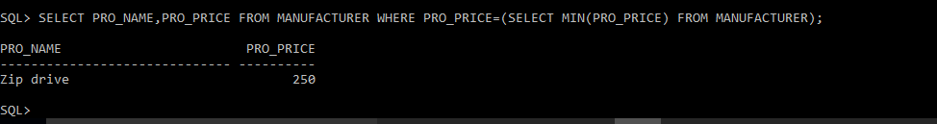

10. Write a query in SQL to find the last name of all employees, without duplicates.

CREATE TABLE EMPLOYEES

(

EMP_IDNO NUMBER(10),

EMP_FNAME VARCHAR2(30),

EMP_LNAME VARCHAR2(30),

EMP_DEPT NUMBER(5)

);

                  ----------------------------------------------

                INSERTION INTO EMPLOYEES TABLE

----------------------------------------------

BEGIN

INSERT INTO EMPLOYEES VALUES(843795,'Enric','Dasio',57);

INSERT INTO EMPLOYEES VALUES(328717,'Jhon','Snares',63);

INSERT INTO EMPLOYEES VALUES(444527,'Joseph','Dosni',47);

INSERT INTO EMPLOYEES VALUES(659831,'Zanifer','Emily',47);

INSERT INTO EMPLOYEES VALUES(847674,'Kuleswar','Sitaraman',57);

INSERT INTO EMPLOYEES VALUES(748681,'Hanrey','Gabriel',47);

INSERT INTO EMPLOYEES VALUES(555935,'Alex','Manuel',57);

INSERT INTO EMPLOYEES VALUES(539569,'George','Mardy',27);

INSERT INTO EMPLOYEES VALUES(733843,'Mario','Saule',63);

INSERT INTO EMPLOYEES VALUES(631548,'Alan','Snappy',27);

INSERT INTO EMPLOYEES VALUES(839139,'Maria','Foster',57);

END;

SQL>SELECT DISTINCT(EMP_LNAME) FROM EMPLOYEES;

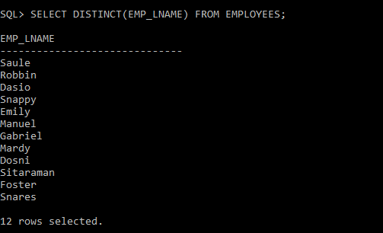

11. Write a query to display all customers with a grade above 100

SQL>SELECT * FROM CUSTOMER WHERE GRADE>100;

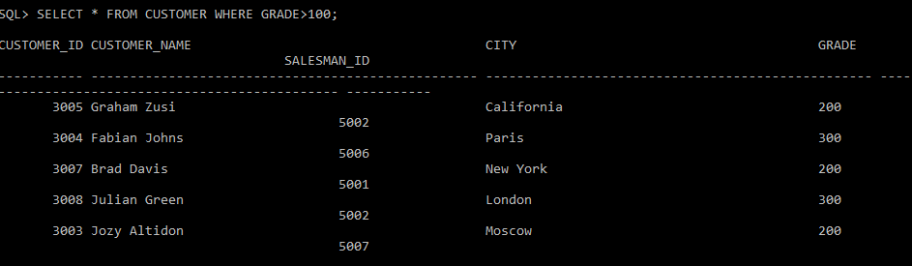

12.Write a SQL statement to display all customers, who are either belongs to the city New York or had a grade above 100 from above table.

SQL>SELECT * FROM CUSTOMER WHERE CITY ='New York' OR GRADE>100;

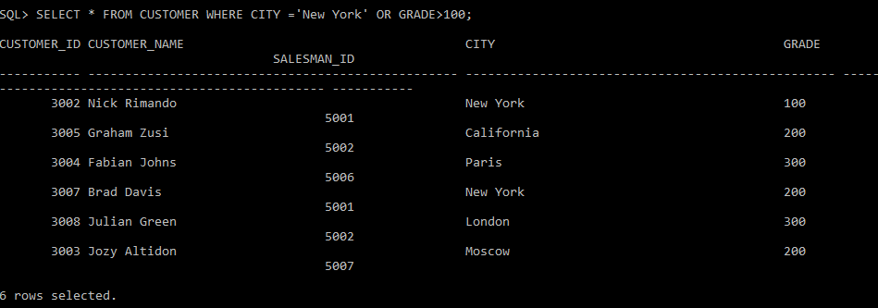

13. Write a SQL query to display those customers who are neither belongs to the city New York nor grade values is more than 100 from above table.

SQL>SELECT * FROM CUSTOMER WHERE CITY !='New York' AND GRADE<100;



CREATE TABLE ORDERS(

ORD_NO NUMBER,

PURCH_AMT NUMBER(10,2),

ORD_DATE DATE,

Customer_id NUMBER,

salesman_id NUMBER);



INSERT INTO ORDERS VALUES(70001,150.5,TO_DATE('2012-10-05', 'YYYY-MM-DD'),3005,5002);

INSERT INTO ORDERS VALUES(70009,270.65,TO_DATE('2012-09-10', 'YYYY-MM-DD'),3001,5005);

INSERT INTO ORDERS VALUES(70002,65.26,TO_DATE('2012-10-05', 'YYYY-MM-DD'),3002,5001);

INSERT INTO ORDERS VALUES(70004,110.5,TO_DATE('2012-08-17', 'YYYY-MM-DD'),3009,5003);

INSERT INTO ORDERS VALUES(70007,948.5,TO_DATE('2012-09-10', 'YYYY-MM-DD'),3005,5002);

INSERT INTO ORDERS VALUES(70005,2400.6,TO_DATE('2012-07-27', 'YYYY-MM-DD'),3007,5001);

INSERT INTO ORDERS VALUES(70008,5760,TO_DATE('2012-09-10', 'YYYY-MM-DD'),3002,5001);

INSERT INTO ORDERS VALUES(70010,1983.43,TO_DATE('2012-10-10', 'YYYY-MM-DD'),3004,5006);

INSERT INTO ORDERS VALUES(70003,2480.4,TO_DATE('2012-10-10', 'YYYY-MM-DD'),3009,5003);

INSERT INTO ORDERS VALUES(70012,250.45,TO_DATE('2012-06-27', 'YYYY-MM-DD'),3008,5002);

INSERT INTO ORDERS VALUES(70011,75.29,TO_DATE('2012-08-17', 'YYYY-MM-DD'),3003,5007);

INSERT INTO ORDERS VALUES(70013,3045.6,TO_DATE('2012-04-25', 'YYYY-MM-DD'),3002,5001);

1. Write a SQL statement to display either those orders which are not issued on date 2012-09-10 and issued by the salesman whose ID is 505 and below or those orders which purchase amount is 1000.00 and below.

SQL>SELECT * FROM ORDERS WHERE (ORD_DATE NOT IN TO_DATE(‘2012-09-10’,'YYYY-MM-DD') AND SALESMAN_ID <=5005) OR PURCH_AMT<=1000;

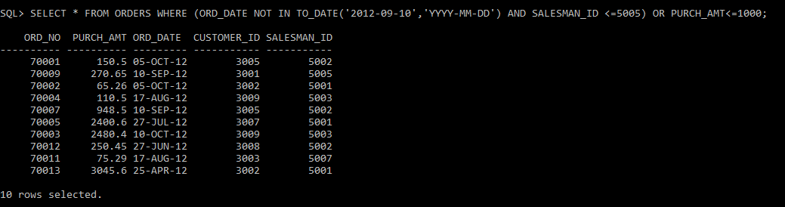

15. Write a SQL statement for above table where i) order dates are anything but not 2012-08-17 or customer_id is not greater than 3005. Ii) and purchase amount is not below 1000.

SELECT * FROM ORDERS WHERE (ORD_DATE NOT IN TO_DATE('2012-08-17','YYYY-MM-DD') OR Customer_id <= 3005) AND purch_amt>=1000 ;

